# 1. Elaberation

…..

## 2.3 Expanded Use Cases

I *expanded Use Cases* beskrives hvert Use Case mere detaljeret med *pre- og postconditions*, et typiske hændelsesforløb og et eventuelt alternativt hændelsesforløb.

Nedenfor er Expanded Use Cases for 1. iteration vist. De resterende *Expanded Use Cases* er vedlagt som bilag XXXX.

|  |  |  |  |
| --- | --- | --- | --- |
| Receive Order | | | |
| Use case: | | **Receive Order** | |
| Actors: | | DSS(Detail Store System) | |
| Purpose: | | Receive Order from DSS and save it in the system. | |
| Overview: | | CSS receives an order from a DSS over a secure socket connection. CSS confirms the identity of the detail store and converts the received order to an active order in CSS and stores it in the system. The system goes through the order and updates the stock by reserving each item in the order and associates it to the order. As the system goes through the order; reserving items, it puts together a Confirmation to send back to the detail store. The Confirmation holds information about which items can be delivered and which is in backorder. | |
| Type: | | Essential | |
| Preconditions: | | The DSS is known by the System. | |
| Postconditions: | | An Order is created in the system and the stock is updated. | |
| Special Req.: | | No special requirements are needed. | |
|  | |  | |
| Flow of Events | | | |
| Actor Action | | | **System Response** |
| 1. This use case starts when a Detail store system sends a request to CSS containing an order and store information. | | | 1. CSS responds to the request and a connection is established. |
|  | | | 1. CSS verifies the Detail store identity. |
|  | | | 1. CSS verifies that the Order is not a duplicate. |
|  | | | 1. CSS convert the incoming order to an order in CSS and store it in the system. |
|  | | | 1. CSS goes through the stock reserving and associating items to the Order. |
|  | | | 1. CSS creates a Confirmation and sends it to the DSS |
| 1. The DSS sends a “Close connection” message to CSS. | | |  |
|  | | | 1. CSS receives the “close connection” message, and closes the connection. |
|  | | |  |
| Alternative Flow of Events | | | |
| Line 2: | CSS rejects the request (return to Line 1). | | |
| Line 3: | CSS cannot confirm the Detail store identity and rejects the order (**return to line 1**). | | |
| Line 4: | CSS find that the order is a duplicate (**go to line 9**) | | |
| Line 7: | The Detail store do not receive a Confirmation from CSS (**return to line 7 until timeout - on timeout go to line 9**) | | |

|  |  |  |  |
| --- | --- | --- | --- |
| View Orders | | | |
| Use case: | | **View Orders** | |
| Actors: | | Admin & Stock | |
| Purpose: | | Display a list of orders for the user to interact with. | |
| Overview: | | The System constructs a list with all orders and makes the list available on display for the user. | |
| Type: | | Essential | |
| Preconditions: | | The user must be known to the System. | |
| Postconditions: | | A list of orders is made available on display for the user. | |
| Special Req.: | | No special requirements needed. | |
|  | |  | |
| Flow of Events | | | |
| Actor Action | | | **System Response** |
| 1. This use case starts when the user requests access to the list of orders. | | | 1. System produces a list of all orders requested and makes it available on display. |
|  | | |  |
| Alternative Flow of Events | | | |
|  |  | | |

|  |  |  |  |
| --- | --- | --- | --- |
| **Store Item** | | | |
| **Use case:** | | **Store Item** | |
| **Actors:** | | Manager, RCS | |
| **Purpose:** | | Store a specific Item on its associated stock position. | |
| **Overview:** | | The item is scanned and its stock position is retrieved from CSS and forwarded to the RCS (Robot Controlled System). The Item is then moved to its associated stock position and its information is stored in the database. | |
| **Type:** | | Essential | |
| **Preconditions:** | | The item type must exist in the system | |
| **Postconditions:** | | The item is added to storage, and the System is updated. | |
| **Special Req.:** | | No special requirements needed. | |
|  | |  | |
| **Flow of Events** | | | |
| **Actor Action** | | | **System Response** |
| 1. The use case starts when Manager puts an item on a storage buffer, and clicks "Store Item" | | | 1. RCS: The conveyer belt transports the item to a scanner, and scans the item. the scanned info is send to CSS |
|  | | | 1. CSS: Looks up the item, using the scanned info, and sends the stock position back to the RCS |
|  | | | 1. RCS. Places the item on its position, and returns a confirmation to CSS. |
|  | | | 1. CSS: updates stock and returns a confirmation to the Manager. |
|  | | |  |
| **Alternative Flow of Events** | | | |
| **Line 2:** | Item type doesn’t exist in the system. Return Item to storage buffer, and notify the Manager. | | |

|  |  |  |  |
| --- | --- | --- | --- |
| Process Order | | | |
| Use case: | | **Process Order** | |
| Actors: | | Manager | |
| Purpose: | | Manager processes an Order, retrieve the ordered Items from RCS (Stock) and ready the Items for shipment. | |
| Overview: | | All items are continuously retrieved from storage. Every time an Item is retrieved it is checked out of the System. When all Items have been retrieved, the order status is changed. | |
| Type: | | Essential | |
| Preconditions: | | Stock positions of Items are known to the System. | |
| Postconditions: | | Order has its State changed to Processed. Items are removed from Stock | |
| Special Req.: | | No special requirements are needed. | |
|  | |  | |
| Flow of Events | | | |
| Actor Action | | | **System Response** |
| 1. This Use Case begins when the Manager wants to process an Order | | |  |
| 1. The Manager requests the Order to be processed. | | | 1. For each Item CSS looks up the Item’s Stockposition and sends a ’Retrieve Item’ with that Stockposition to RCS. RCS retrieves the Item and responds with a ’retrieved’. CSS removes the Item from Stock. On last Item the State of the Order is changed to Processed. |
|  | | |  |
| Alternative Flow of Events | | | |
| Line 3: | If RCS responds with ’failure’, CSS indicates a ’failure’ for that Stockposition. CSS then looks up another ’not reserved’ Item of same Itemtype and retrieves it instead. If no available Item CSS indicates a ’failure’ for retrieving that Item. | | |

Retrieve Item blev ned prioteret i fordel af de 4 som er beskrevet. Grunden til dette er, at det er en use case som kører på RCS. Og ikke på CSS som de andre 4 gør.

## 2.4 System-sekvens Diagrammer

System sekvensdiagrammerne viser aktørens interaktion med systemet. Allerede her kan vi begynde at se, at de SCRUM point vi havde givet hver use case måske ikke ville være korrekte. Som tidligere beskrevet havde vi givet Receive Order 30 point. Denne beslutning blev taget fordi vi ikke havde et overblik, over hvad det krævede at modtage en besked fra et andet system.

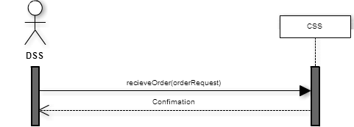

View Order har stadig 8 point, den fremgår stadig som en simpel use case.

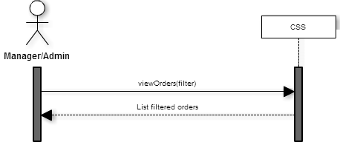

Retrieve Item er blevet opdøbt til process order, så den nu behandler en del order i stedet for kun et item. På baggrund at disse diagrammer virker use case ikke til at være mere kompliceret ind først antaget. Udover at der skal loopes over flere items.

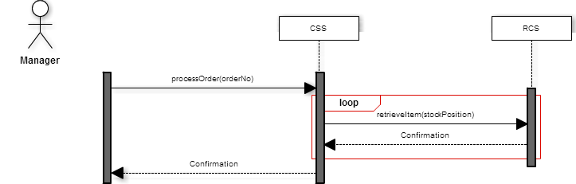

Store item er blevet en lille smule mere kompliceret end Process order, men den virker stadig relativt let.

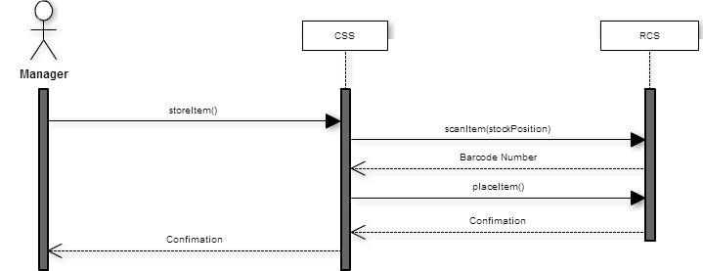

## Domain Model:

Ud fra de ting vi havde snakket om da vi lavede sekvens diagrammerne, har vi alle en forståelse for hvilke koncepter vores domain model skulle indeholde. Dette er den første:

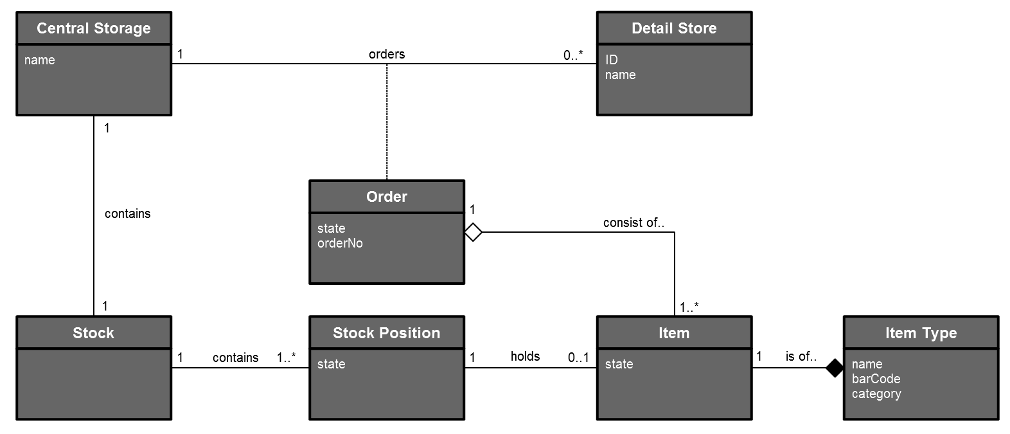

Som hurtigt blev skrevet om til denne:

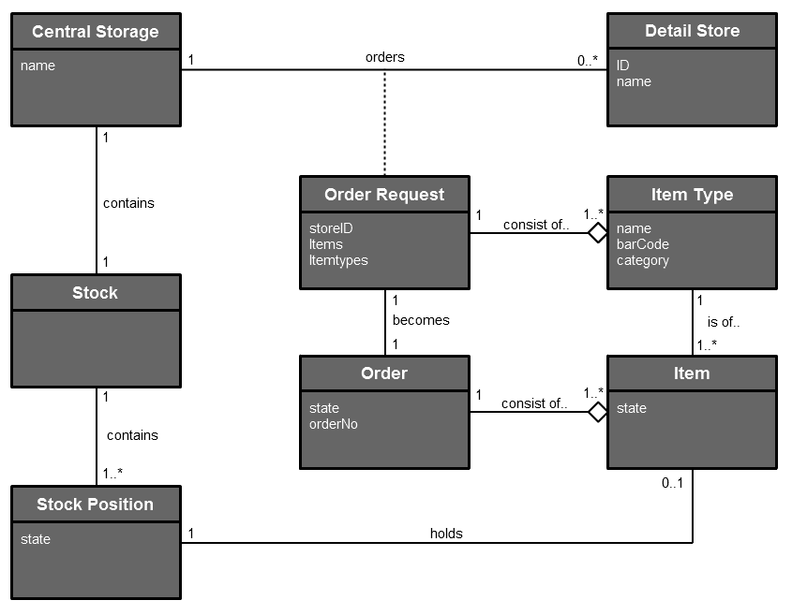

Grundet ikke dette var at en ordre ikke indeholdte et konkret item, men en item type. En Detail Store sender en orderRequest med en liste af item types. Når systemet så omskriver denne orderRequest til en konkret order, bliver konkrete item tilknyttet denne order.